EMFDriver step by step
( Eclipse version 2.1 and EMF version 1.1
& Eclipse version 3, EMF version 2 )

Part I : Transforming Ecore models

Skip directly to step 2 of PART II.

Part II : Transforming user defined models(with ECLIPSE 2 EMF1.1)

Let’s take the « library.ecore » example from EMF tutorials.

1 – If not already done, generate the model code and editor for your defined model

Import the library.mdl Rose model available in the EMF tutorials

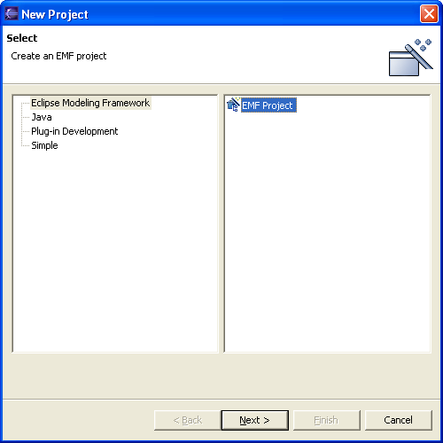

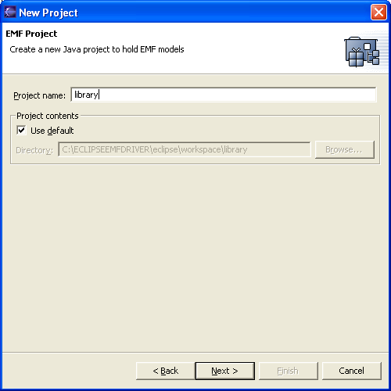
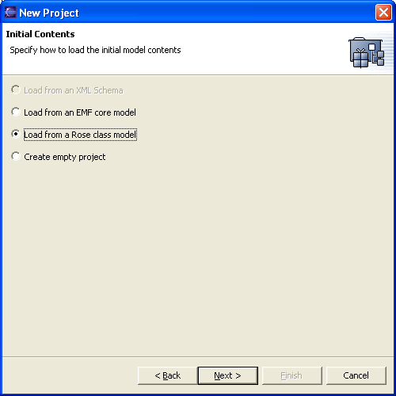
Select the directory where you stored the .mdl model file :

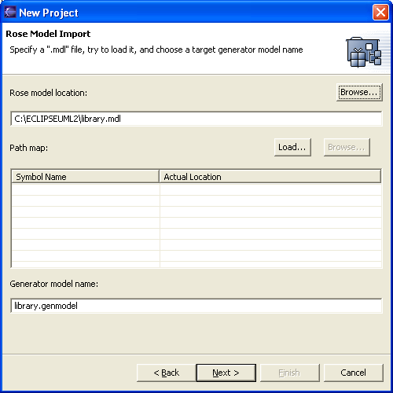

Choose the package you want,

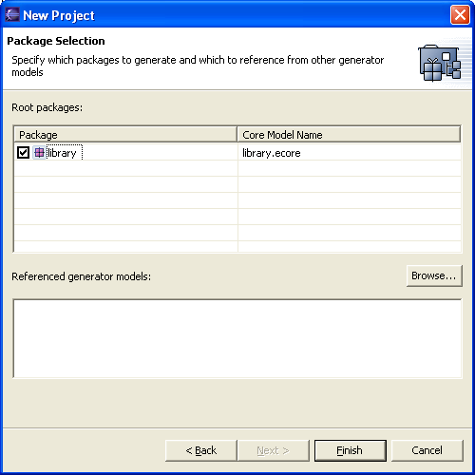

You’ll get the library plug-in project.
Check the contents of your model if necessary (the property sheet should automatically appear after the project creation; if not, select Show_View=>Basic=>Properties and then double-click on the library.genmodel in the library/src/model hierarchy) :
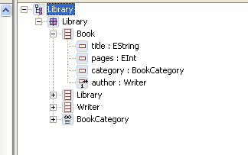

Select Generate_All to get the model code, edit framework and editor (2 more projects ) :
(Always on the Top level part, or you’ll miss some generated elements )
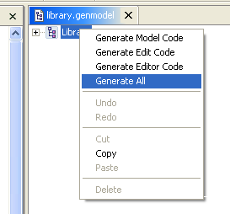
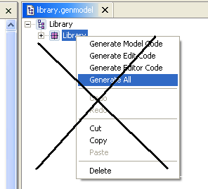

2 – Create your transformation program in a plug-in project

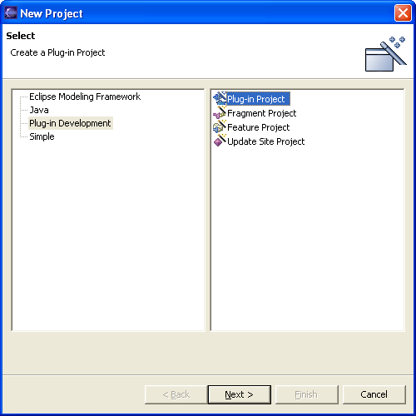
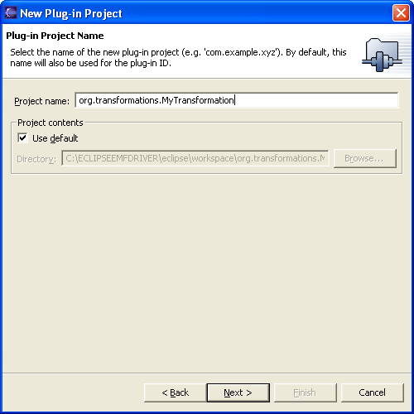

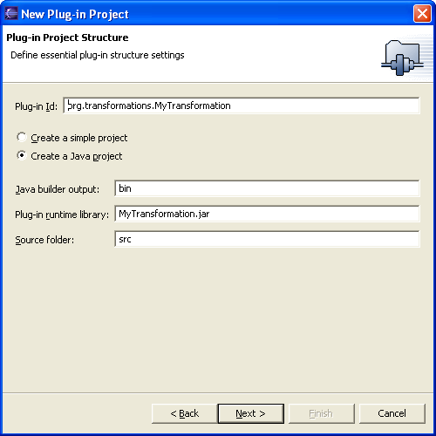

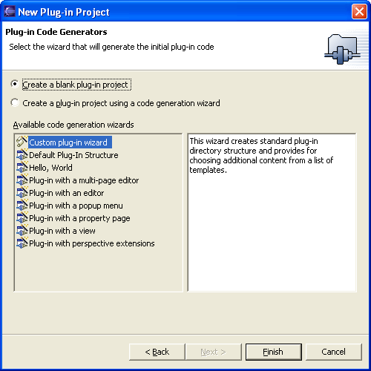

Write your .mtl program and compile it. With a build.xml script this could give you something like :
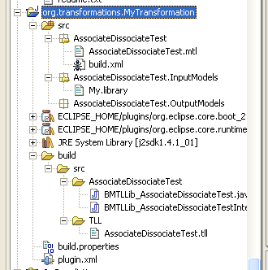

Edit now the plugin.xml file (last file here above) with the Plugin manifest editor.
Add the <EMFDriver as dependency :
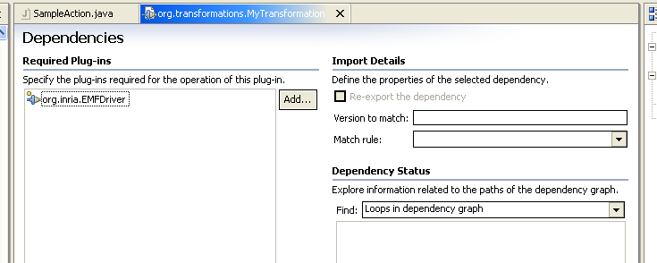

Add the build/src directory in the sources folder of the JavaBuildPath
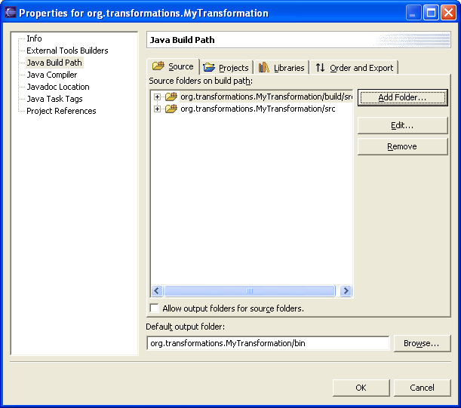
3 – Running your transformation

Open the “TransformationLauncher” project and edit the “SampleAction.java” file.
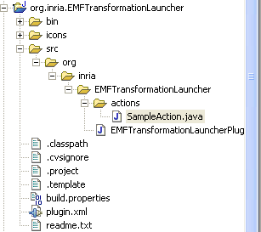

The edition of SampleAction may lead to have some java errors due to Classpath. We will cope with errors later, first modify the file in the intended way to run your transformation program.
Put your transformation program package in the import part of this file :

//***************************************************************
//===============================================================
//change this import according to the application you want to run
import AssociateDissociateTest.*;
//==============================================================

, For “User defined models” (not .ecore files) also put the necessary model elements (Package, Factory, ItemProviderAdapterFactory) in the import section :

/******** CHANGE TO THE APPROPRIATE FACTORY FOR THE MODEL YOU WANT TO ACCESS
* *************************************************************************
* =========================================================================
*/
import org.eclipse.example.library.impl.LibraryFactoryImpl;
import org.eclipse.example.library.LibraryPackage;
import org.eclipse.example.library.LibraryFactory;
import org.eclipse.example.library.provider.LibraryItemProviderAdapterFactory;

/* *************************************************************************
* =========================================================================
*/
For “User defined models” (not .ecore files), add an editing domain provider for your model :

/******** CHANGE TO THE APPROPRIATE FACTORY FOR THE MODEL YOU WANT TO ACCESS
* *************************************************************************
* =========================================================================
*/
EditingDomainProvider provider2 = new EditingDomainProvider("library",new LibraryItemProviderAdapterFactory());

String libraryPackageURI = LibraryPackage.eNS_URI;
LibraryPackage libraryPackage = (LibraryPackage) registry.get(libraryPackageURI);
LibraryFactory libraryFactory = libraryPackage.getLibraryFactory();
provider2.setRootElement(libraryFactory.createLibrary());

EMFDriver.addEditingDomainProvider("library",provider2);
/* *************************************************************************
* =========================================================================
*/

Endly, call the transformation procedure you defined in your transformation program :

//RUN THE APPROPRIATE APPLICATION BY CALLING ITS ENTRYPOINT METHOD
try {
new BMTLLib_AssociateDissociateTest().BMTL_runTransformation();
}
catch (Throwable e) {System.out.println("Application terminated with exception :"+e);
e.printStackTrace();}

For “User defined models” (not .ecore files), add the above line to dispose the editing domain provider at the end of your transformation :
/******** CHANGE TO THE APPROPRIATE PROVIDER TO DISPOSE
* *************************************************************************
* =========================================================================
*/
provider2.dispose();
/* *************************************************************************
* =========================================================================
*/

Notes : - By default an Ecore edition domain is always provided. You may remove lines for ecore provider if you don’t intend to manipulate ecore models.
- You may activate any number of transformations programs, and on several different models from this atrat action.
Now edit the plugin.xml file with the plugin manifest editor, and choose the “Dependencies”tab within it.
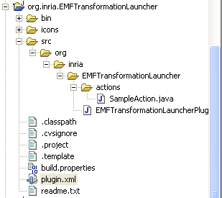
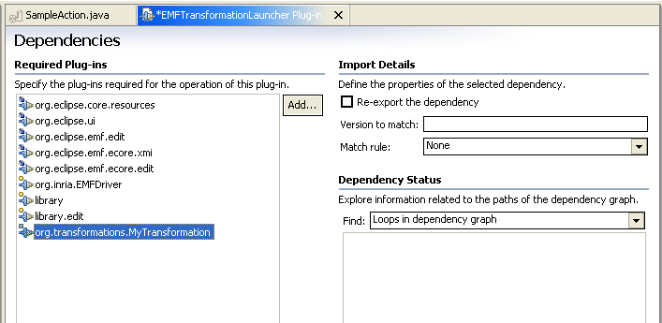

Add your model, its edit framework and your transformation project as dependencies.
Close the plugin manifest editor to update the changes.

You may still have errors due to classpath, but your transformation program may run with this plugin configuration.
To remove remaining errors, edit the transformationLauncher project properties and add dependencies to your model, its edit framework and your transformation project :
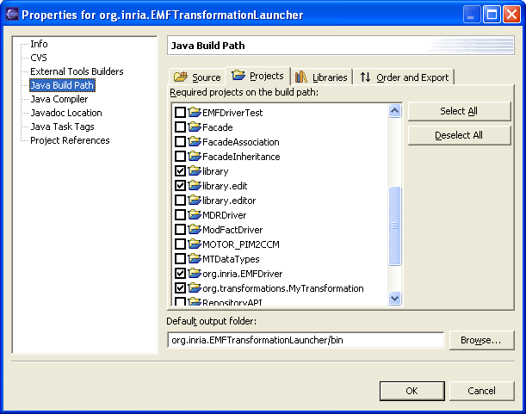
( this should be automatically updated afyer plugin.xml edition )
You should have no errors now in your workbench.

You also need to have the BasicMTLruntime.jar in your plugin-project Classpath to avoid errors from generated java files (obtained by .mtl files compilation). Edit the properties=>JavaBuildPath=>Libraries to add the necessary jar file :
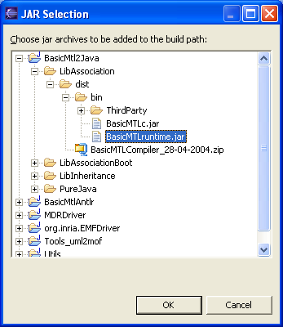

Note that plugins may run and find the BasicMTLruntime.jar file because this one id declared locally to the org.inria.EMFDriver plugin (runtime item in the manifest editor). Of course, if you rebuild a new compiler version, you need to make the above link to the new BasicMTLruntime.jar version, and copy it into the org.inria.EMFDriver project so that plugins work with the new compiler version.
Is all clean ? So, let’s run the transformation from a new workbench.

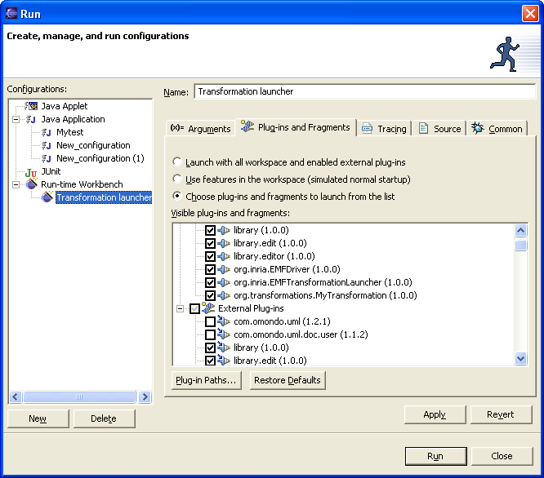

Click on the Transformation=>run Transformation menu to launch your transformation :

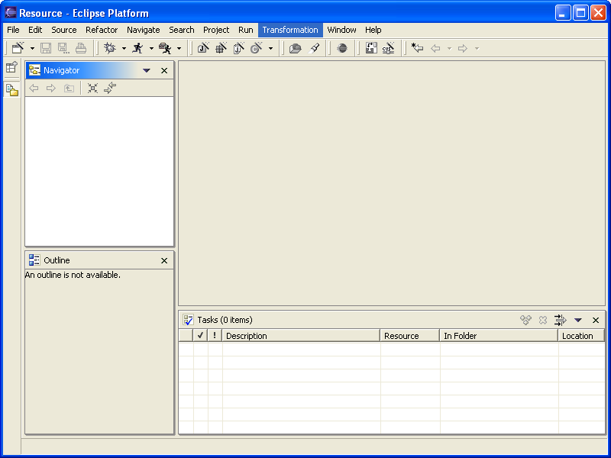

If the “Transformation” menu does not appear in your new workbench :
Select Window=>CustolizePerspective and set the “other” item :

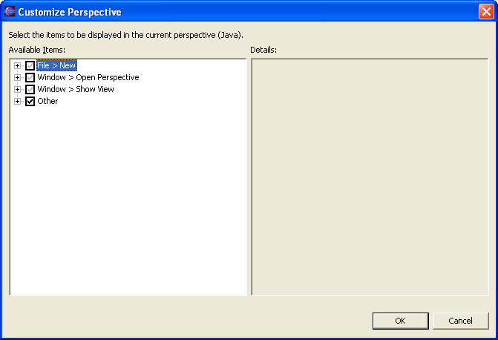
Part III : Transforming Ecore and user defined models(with ECLIPSE 3 EMF 2)

1 – SPECIFIC INSTALLATION for ECLIPSE 3 with org.eclipse.osgi plugin (M8 release)
Some changes on plugin.xml and plugin.dependencies have been done in Eclipse 3 recent releases. The easiest way is to have two plugin versions, one for old Eclipse platforms, one for recent ones (see plugin changes description in the ECLIPSE 3 Help Contents=>Platform plug-in developer guide=>Porting Guide =>Eclipse3 Porting guide).

After you’ve got all necessary projects from CVS :

- Replace EMFDriverTest, org.inria.EMFDriver and org.inria.EMFTransformationLauncher project contents by the ECLIPSE3M8VERSION folder contents located in these projects.
- Open the BasicMTL2Java project build.properties.samples/ECLIPSE3M8VERSION directory;
- copy the LibInheritance_build.xml and LibAssociation_common_build.xml to replace the existing ones in the BasicMTL2Java project.
- copy the M8 (or later)_BuildDate_build.properties into the BasicMTL2Java top level and rename it build.properties.

You may now rebuild the entire compiler (build antlr project and refresh it; then launch build.xml from BasicMTL2Java project ).

2 – Using the EMFDriver with Eclipse M8 and EMF 2
The procedure is quite the same as in Part II, but some “Eclipse 3” dialog box are different.
Here are the major differences :

Defining an EMF project :
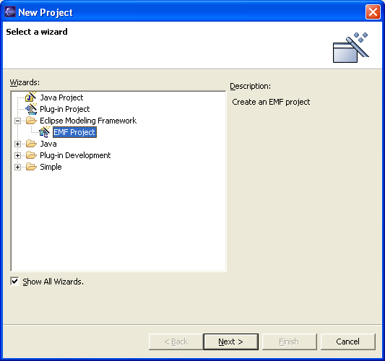

Defining a plugin project for your transformation application :

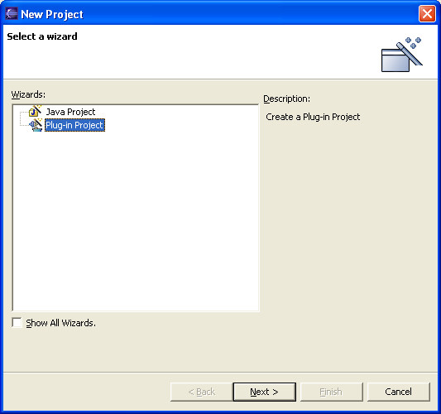
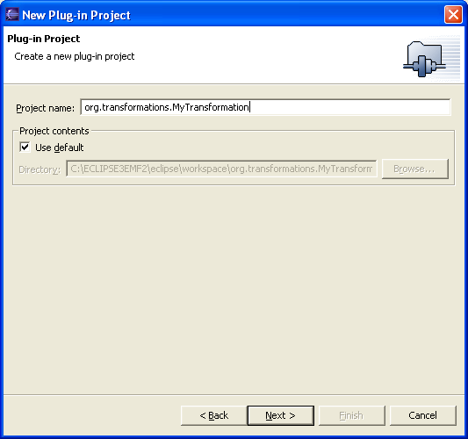

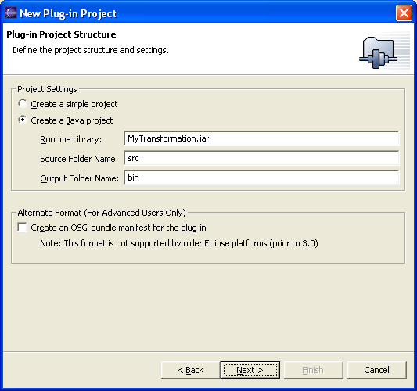

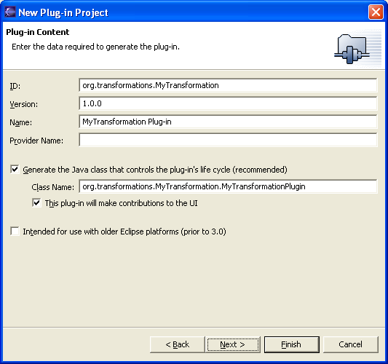

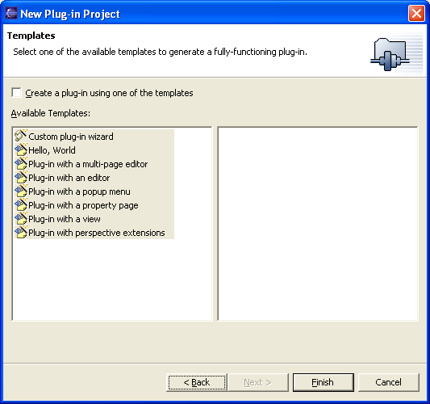
To make the menu “Transformation” appear in the new workbench :
As previously (part II) select Window=> CustomizePerspective then make
The “Sample Action Set” item available, and click OK.
